Some people think that zoos are cruel and all zoos should be closed.
However, others think zoos are useful to protect rare animals.
Discuss both views and give your opinion.
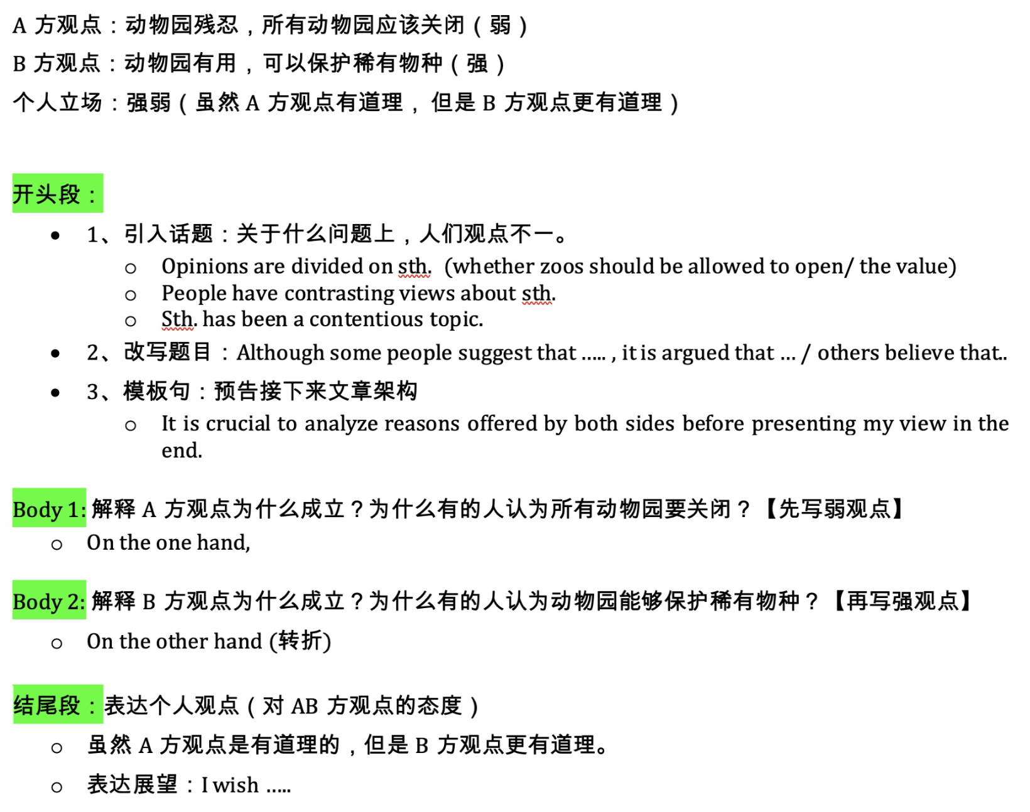

Discussion题型中，留意题目是否有极端观点存在，如果有，那就不能同意它，从而倾向于另外一个比较平和的观点。如果双方观点都有各自的道理，可以折中一下，采取一个平衡的观点。

【题目分析】
A = Some people think that zoos are cruel and all zoos should be closed.
Cruel: 动物管理员虐待动物;
B = However, others think zoos are useful to protect rare animals.
Useful, rare animals: zoos可以保护珍惜物种，濒危野生动物

Discussion题型的包含两个观点，要分别讨论。
两个观点属于前弱后强，所以段落排序如下：
【BP1】zoos are cruel and should be closed （弱认同）
zookeepers—animals are abused—bears—boycott of the zoo
【BP2】zoos are useful to protect rare animals （强认同）
Zoos offer professionally-run breeding programs—pandas—without them, animals die out
一些动物园确实虐待动物，应该治理，但是全部关闭太极端了，因为动物园确实在保护珍稀动物方面有巨大的作用。

【开头段】①动物园是否应该关闭一直是一个有争议的话题（引入话题）。②尽管许多专家都是动物园的坚定支持者，但也有一些动物权利的积极份子强烈反对这类机构的存在(改写题目) 。③我们必须研究双方提出的理由(模版句)。

①Whether zoos should be closed or not has been a contentious topic. ②Although many experts are adamant supporters of zoos, there are animal rights activists fervently opposing the existence of such institutions. ③It is important to examine reasons offered by both sides.

- A contentious topic 一个有争议的话题
- Adamant supporters 坚定支持者 （adamant /'ædəm(ə)nt/ adj. 坚定不移的）
- Animal rights activists 动物权利的积极分子
- Fervently agree / oppose 强烈赞同/反对 （fervently /'fə:vəntli/ 热烈地，强烈地）
- It is important to examine reasons offered by both sides before presenting my own opinion in the end. 我们必须研究双方提出的理由

【BP1–观点A】TS + 解释 + 举例 + 进一步的结果 + 重申观点
【BP1–观点A】①认为不应允许动物园开放的人认为，强加给动物的残酷行为是一个重要因素。 (观点A) ②有些动物园管理员和工作人员残酷对待动物，给动物带来难以忍受的痛苦 (解释)。③如我国某动物园的几只黑熊在饲养员的手中被虐待，憔悴而死 (举例)。④这一令人痛心的故事激起了公众对这家动物园的愤怒，从而引发了人们对它的抵制 (进一步的结果)。⑤所以，为了防止今后类似的悲剧再次发生，呼吁关闭所有动物园似乎是合理的。(重申观点)

①Those who believe zoos should not be allowed to open cite the cruelty imposed on animals as a significant factor. ②Some zookeepers and staff treat animals brutally, causing unbearable suffering to them. ③For instance, in my country, several black bears in a zoo were abused at the hand of their keepers and pined to death. ④This heartbreaking story fueled the public’s outrage at this zoo and therefore triggered a boycott of it . ⑤So, in order to prevent similar tragedies from reoccurring in the future, it seems reasonable to call for the shutdown of all zoos.

- 怎么表达“残忍对待动物”：taking away the life of any creature 终结动物的生命，这本身就是残忍的; farming的过程就是残忍的，动物的living condition很差，剥夺freedom, 没有被当成生物看待，而是be treated as a commodity ～
- Zoos should be closed = zoos should not be allowed to open = the shutdown of zoos
- The cruelty imposed on animals 强加给动物的残酷行为
- Treat animals brutally 残酷对待动物
- Unbearable suffering 难以忍受的痛苦
- Be abused 被虐待
- Pine to death 憔悴致死，消瘦致死
- Fuel the public’s outrage 激起公众的愤怒
- Trigger a boycott 引发抵制
- Prevent similar tragedies from reoccurring in the future 防止今后类似的悲剧再次发生
- People have no right to subject animals to this kind of trauma, and the lives of all creatures should be respected.

【BP2–观点B】TS + 解释 + 举例 + 假设 + 进一步的结果
【BP2–观点B】①另一方面，有一批专家认为，动物生活在动物园里是有好处的。(观点B) ②这是因为众多的动物园提供了专业的繁殖计划，可以大大增加珍稀动物的生存机会。(解释) ③大熊猫是说明这一点的典范，在动物园里受到精心的照顾，生活舒适。 (举例) ④如果没有专家的辅助，它们在自然环境中的生存能力迟钝，早就灭绝了(假设)。⑤这样一来，不仅世界将失去一种可爱的生物，人类也将失去研究它的机会。(进一步的结果)

①On the other hand, a group of experts believe that animals benefit from living in zoos. ②This is because numerous zoos offer professionally-run breeding programs which can significantly increase the chance of survival for rare animals. ③Pandas are a paradigm to illustrate this, being taken care of meticulously in zoos and living a comfortable life. ④Without the aids of specialists, they would have been extinct due to their retarded ability to survive in a natural habitat. ⑤Then not only would the world lose an adorable creature, but human beings would be denied the chance to study it.

- Benefit from doing sth. 做..是有好处的
- Professionally-run breeding programs 专业的繁殖计划
- Increase the chance of survival for rare animals 增加稀有物种存活的机会
- Paradigm /'pærədaɪm/ 范例
- Retarded ability 迟钝的能力
- An adorable creature 可爱的生物
- Be denied the chance to do sth. 被剥夺了机会，丧失了机会

【结尾段-我的观点：强弱】①权衡之下，我想说的是，一些动物确实因为动物园里不道德的工作人员而遭受了很多痛苦，这种不道德的行为应该立即被制止；②但是，说动物园都不值得存在的说法过于狭隘，没有认识到动物园在保护濒危动物方面所发挥的重要作用。③我希望所有的动物园都能得到适当的监管，成为濒危物种的避难所。

①On balance, I would say that some animals do suffer much pain caused by immoral workers in zoos, and this unethical behaviour should be stopped immediately; ②however, the claim that none of the zoos deserves to exist is too narrow-minded, failing to recognize the essential role played by them in preserving endangered animals. ③I wish all zoos could be regulated appropriately and become a sanctuary for threatened species.

- Immoral = unethical 不道德的
- The claim that ….. is too narrow-minded 说法过于狭隘
- A sanctuary for threatened animals 濒危物种的避难所

